**COVID19 Live Data Tracker and Alert System**

Alokam Nikhitha

SCOPE

Vellore Institute of Technology

Vellore, India

[alokam.nikhitha2019@vitstudent.ac.in](mailto:alokam.nikhitha2019@vitstudent.ac.in)

Harshit Mishra

SCOPE

Vellore Institute of Technology

Vellore, India

[harshit.mishra2019@vitstudent.ac.in](mailto:harshit.mishra2019@vitstudent.ac.in)

Pankaj Shivnani

SCOPE

Vellore Institute of Technology

Vellore, India

[pankaj.shivnani2019@vitstudent.ac.in](mailto:pankaj.shivnani2019@vitstudent.ac.in)

Galla Kiran

SCOPE

Vellore Institute of Technology

Vellore, India

[galla.kiran2019@vitstudent.ac.in](mailto:galla.kiran2019@vitstudent.ac.in)

Prof. Abdul Majeed K K

SENSE

Vellore Institute of Technology Vellore, India

abdulmajeed.kk@vit.ac.in

**Abstract *-- COVID19 is a novel coronavirus disease that causes illnesses ranging from the common cold to more severe diseases. It had a devastative effect on humanity worldwide resulting in the complete disruption of normal life. Due to its effect on humanity COVID19 was declared a pandemic by World Health Organisation in March 2020. The pandemic is far from over and we are in need of a cautious yet systematic approach in order to minimize its effect and spread in near future.***

***In order to aid the process of systematic governance, we are trying to implement a COVID19 Live tracker and alert system that informs a user about the current situation of the pandemic in his/her locality. While we display the real-time data to our users, we also alert them to strengthen their precautionary measures when the number of cases exceeds a given total. We have also demonstrated the working of a social distance detector which could come in handy to enforce the globally accepted 6-feet distance rule of minimizing COVID spread.***

***Keywords—*COVID19, Thingspeak, Social Distance detector, Node MCU, Tinker CAD, LED ,LCD**

**I. INTRODUCTION**

Our proposed model for live tracking the COVID data involves using the real time data as uploaded by common and reliable website sources. We are scraping the data of use, that involves counts such as total cases of a particular state or active cases of a particular state, etc. We then pass this data to our LCD using a Wi-Fi module of NodeMCU(ESP8266) and display it to our users.

The alert system works on a simple if and else condition. Similar to a tracking system, we parse in the active number of active cases, of a particular state, as our conditional statement. We also fix a threshold value that acts as an indicator to our alert system and if the threshold limit is breached by the active number of cases, we activate the alert systems.

The social distance detector uses an ultrasonic distance sensor to find the range of another being within 6-feet and it comes with an added buzzer that turns on when the distance is less than 6-feet.

**II. DRAWBACKS IN EXISTING SYSTEM**

The existing approaches of this particular type of project includes live weather tracking that update once a day. Our project is more robust as it shows us the live count as soon as it is updated in the source webpage. Not only this, the existing system use cloud servers which renders the data with some delay. We have tried to minimize the data fetching by using ThingSpeak API. We have thus tried to improve the speed of data rendering in our project. The pre-existing project which involved health monitoring system needed a manual update once in a while through their equipment, while our project being robust fetches real time data and is fully automated with the help of python script that automatically scrapes a particular page for us. The papers proposed above involves various parameter checks which make the project expensive. The parameter checks are not necessary in our idea as we are scraping a free web page and need no input reading from microcontroller’s environment and hence offer a very low price for the same service offered in the papers referred.

**III. PROPOSED WORK**

There is exists no paper that proposes the data tracking of Coronavirus cases. The existing approaches included health monitoring system or weather applications. This clearly suggests that the idea of our project is relatively novel and new. The other thing that we have added on to our project is the alert system. The alert generally finds its use in burglary alarm system, but we have used the same idea to be implemented in this case of detecting coronavirus cases. Finally, we have also demonstrated the working of social distance detector which is completely new to this field. The distance detector is used in automated robotic systems like self-driving cars or industrial robots. We have used the same approach to make our social distance detector by adding a limit of 6-feet and adding a buzzer to it. This gives a completely new dimension to our COVID19 Live tracker and alert system.

**IV. BLOCK DIAGRAM**

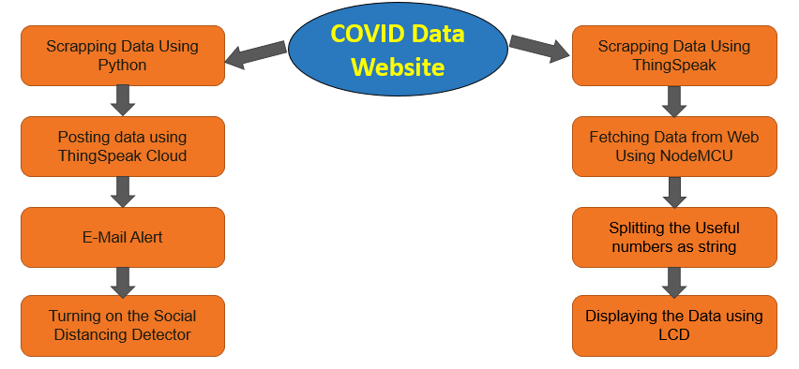

**V. IMPLEMENTATION**

**A. Live Data Tracker:**

The live count is fetched from Zee news’ official website.The Scrapped data is auto-updated in ThingSpeack Cloud.The Arduino is coded in an online editor and then is burned with our NodeMCU.The LCD is connected with our NodeMCU to display our live data.

**B. E-mail Alert System:**

The electronic mail system employs coding in MATLAB.The implementation is done using conditional branching in MATLAB.The number of active cases is considered and based on it an alert is sent to the fed email address of user.

**C. Social Distance Detector:**

The software simulation of social distance detector is demonstrated using Tinkercad.It uses ultraviolet sensors that detect the distance if a particular object enters its range.It is added with a buzzer which starts when the range is less than the specified limit.

**Flow Chart:**

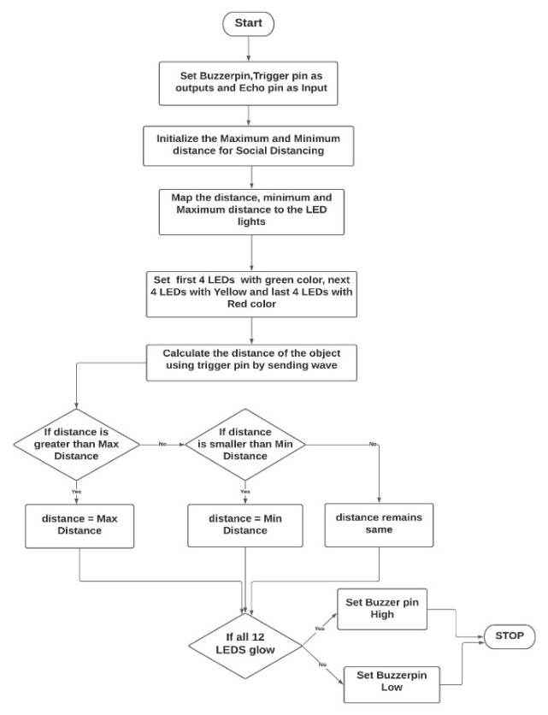

**Pin Diagram**

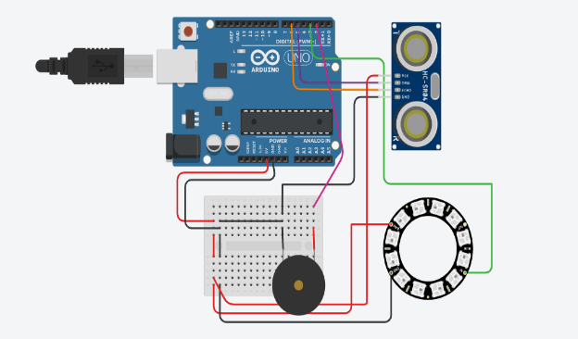

**VI. RESULTS**

**A. Social Distance Detector:**

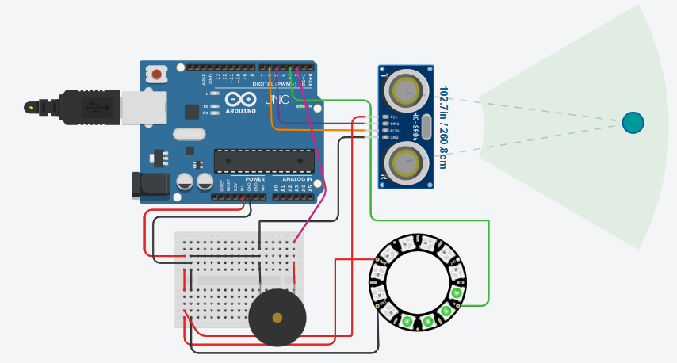

When social distance is maintained

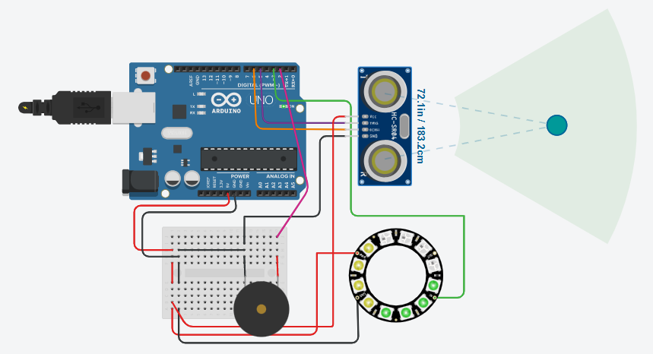

When the distance is still fine but just in range of 6-feet

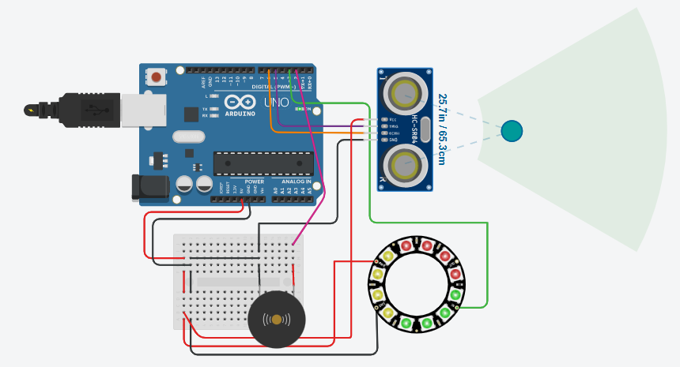

When distance is less than 6-feet

**B. Live Counter**

Live cases,recovers,deaths and active cases from each state will be displayed in the LCD that is connected.

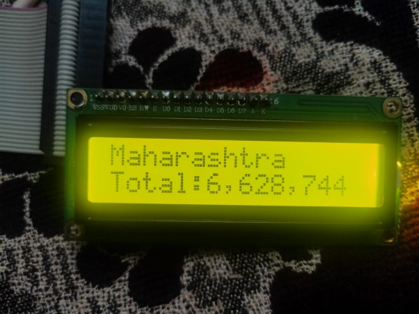

Total Cases in Maharashtra

The total number of Cases in Maharashtra are displayed in the LCD from Thingspeak cloud

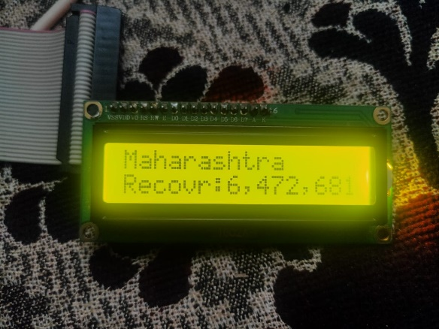

Total Recovered Cases in Maharashtra

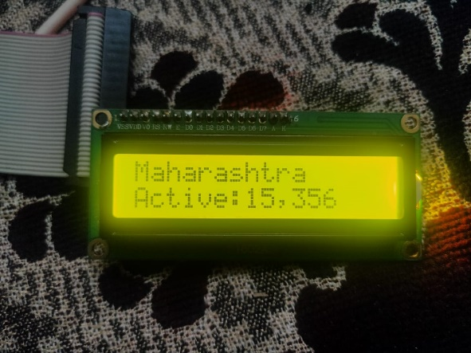

Number of Active Cases in Maharashtra

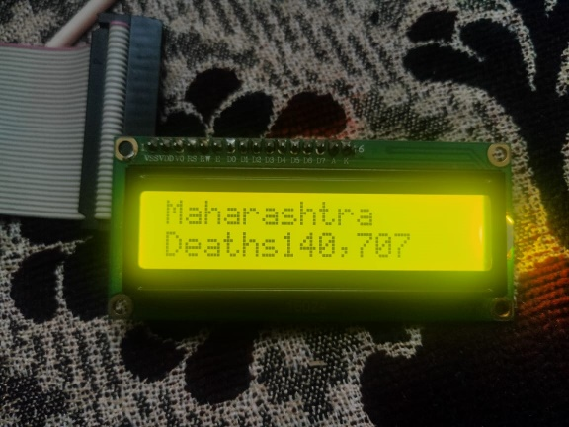

Total Deaths in Maharashtra

Total number of recovered cases ,Active cases and Deaths in Maharashtra are displayed in LCD. All the data is displayed with an interval of 5seconds. After every 5 seconds it will show new information on the LCD screen.

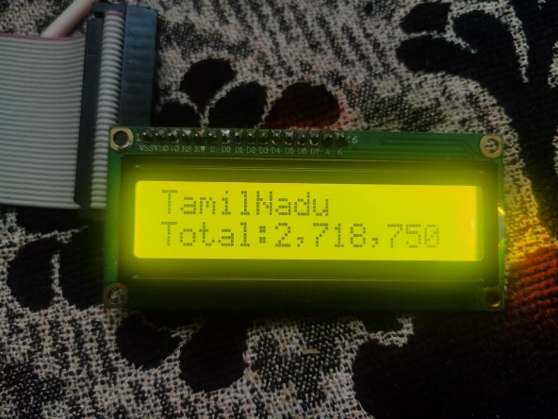

Total Cases in Tamil Nadu

These are Total Number of cases in Tamil Nadu. Similarly we can also display the cases from various states.

**C. E-Mail Alert:**

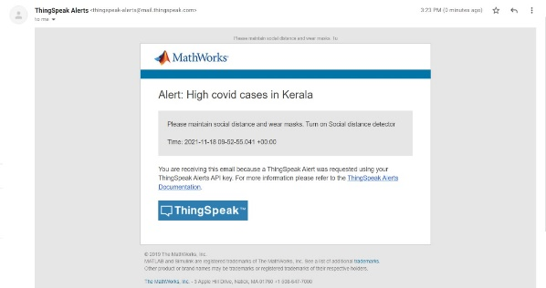

E-mail Alert

An alert email will be sent to the registered Email-Ids , whenever there is an increase in Covid cases in their State.

**VII. CONCLUSION**

Hence, We have successfully Implemented a Live Covid Tracker with an Email Alert System . And also showed the live count as soon as it is updated in the source webpage in a LCD which is connected with our NodeMCU to display our live data. We also implemented a Social Distance Detector which detects if social distance is maintained or not and glow LEDs based on the distance and also give an alert buzzer if the distance goes less than min distance.

**REFERENCES**

[1] S. L. Jurj, R. Rotar, F. Opritoiu and M. Vladutiu, "White-Box Testing Strategy for a Solar Tracking Device Using NodeMCU Lua ESP8266 Wi-Fi Network Development Board Module," 2018 IEEE 24th International Symposium for Design and Technology in Electronic Packaging (SIITME), 2018, pp. 53-60, doi: 10.1109/SIITME.2018.8599250.

[2] Ganorkar, Ankur. (2020). Live Tracking System. International Journal of Engineering Research and. V9. 10.17577/IJERTV9IS060770.

[3] Menni, C., Valdes, A.M., Freidin, M.B. et al. Real-time tracking of self-reported symptoms to predict potential COVID-19. Nat Med 26, 1037–1040 (2020).

[4] Tole Sutikno, Hendril Satrian Purnama, Anggit Pamungkas, Abdul Fadlil,Ibrahim Mohd Alsofyani, Mohd Hatta Jopri:Internet of things-based photovoltaics parameter monitoring system using NodeMCU ESP8266 International Journal of Electrical and Computer Engineering (IJECE) Vol. 11, No. 6, December 2021, pp. 5578~5587 ISSN: 2088-8708, DOI: 10.11591/ijece.v11i6.pp5578-5587

[5] Md Khaja Pasha, G Aruna:DESIGN OF REAL-TIME WEATHER MONITORING SYSTEM BASED ON MOBILE APPLICATION USING ESP8266Vol 10,Issue 11, NOV/2019 ISSN NO:0377-9254

[6] S. Saha and A. Majumdar, "Data centre temperature monitoring with ESP8266 based Wireless Sensor Network and cloud based dashboard with real time alert system," 2017 Devices for Integrated Circuit (DevIC), 2017, pp. 307-310, doi: 10.1109/DEVIC.2017.8073958.

[7] Škraba, A. Koložvari, D. Kofjač, R. Stojanović, V. Stanovov and E. Semenkin, "Prototype of group heart rate monitoring with NODEMCU ESP8266," 2017 6th Mediterranean Conference on Embedded Computing (MECO), 2017, pp. 1-4, doi: 10.1109/MECO.2017.7977151.

[8] S. Halder and G. Sivakumar, "Embedded based remote monitoring station for live streaming of temperature and humidity," 2017 International Conference on Electrical, Electronics, Communication, Computer, and Optimization Techniques (ICEECCOT), 2017, pp. 284-287, doi: 10.1109/ICEECCOT.2017.8284683.

[9] T. Thaker, "ESP8266 based implementation of wireless sensor network with Linux based web-server," 2016 Symposium on Colossal Data Analysis and Networking (CDAN), 2016, pp. 1-5, doi: 10.1109/CDAN.2016.7570919.

[10] Sharmad Pasha : Thingspeak Based Sensing and Monitoring System for IoT with Matlab Analysis International Journal of New Technology and Research (IJNTR) ISSN: 2454-4116, Volume-2, Issue-6, June 2016

[11] Hasan, M. W. (2021). Covid-19 fever symptom detection based on IoT cloud. International Journal of Electrical and Computer Engineering, 11(2), 1823.

[12] Mukherjee, R., Kundu, A., Mukherjee, I., Gupta, D., Tiwari, P., Khanna, A., & Shorfuzzaman, M. (2021). IoT-cloud based healthcare model for COVID-19 detection: an enhanced k-Nearest Neighbour classifier based approach. Computing, 1-21.

[13] Fernandez, L. G. V., Gonçalves, R. T., dos Santos, J. C., Moreira, T. C. P., Nery, J. F. P., de Carvalho, L. M., & de Souza, F. H. B. (2021). Internet of Things versus Covid-19: Integrated Low-Cost Proposal for Oximetry Collection and Data Availability in Cloud for Strategic Management of Population in Isolation. Proceedings of The 3rd International Co.

[14] PRIYANKA B. POPHALKAR: IoTBased Smart Patient Monitoring System withEmphasis onCOVID andAssociatedRespiratory Diseases DiagnosisPriyanka BPophalkar1,Vasif AhmedINTERNATIONAL JOURNAL OF PROGRESSIVE RESEARCH IN SCIENCE AND ENGINEERING, VOL.2, NO.6, JUNE 2021.

[15] D.Dinesh , I.Anette Regina Department of Computer Science, Muthurangam Government Arts College (Autonomous), Vellore:Prediction and Effective Monitoring of Flood Using Arduino System Controller and ESP8266 Wi-Fi Module International Journal of Communication and Networking System Issue: 01, June 2019